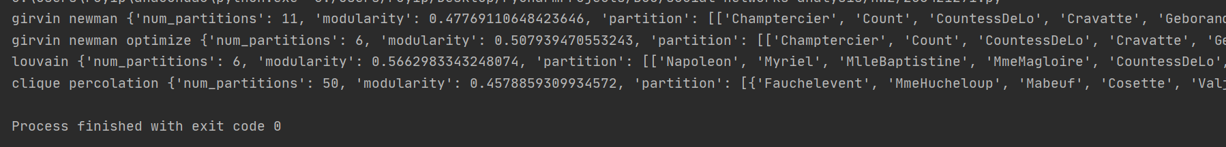**Q1.3**

* The algorithem with **the best modularity is Louvain**.
* girvin newman algorithem is slower with optimizer, and there is a little difference between girvin newman to girvin newman with edge optimizer.
* The algorithm **clique percolation make some issue**, because he drops nodes from the network and he return the communities with one nodes in more then one community.

We should decide what we choose to do. We should to attribute the nodes to one of the communities or make them as community by them self.

* ‘edge_selector_optimizer’ didn’t achieve the best ‘modularity’ value, I tried to add a random noise, the modularity a little bit improved but its not enough.

**Q2.4**

* When we run Girvin Newman over the network, we can see that **without adding new nodes** to the network, the modularity is pretty high, **while the** **non_parliamentarians_nodes is getting bigger**, we should add more nodes to the network and the **modularity will decrease.**
* Compare the communities detected at the two networks we can see that the Right and Left blocks are bigger (more nodes) and the Center block is divided to smaller communities.
* I can identify a few political players in the Right block which are have edges with the central or the left blocks.
* Allowing the extra nodes didn’t prove useful finding an optimal partition. First, the modularity getting smaller while we are adding extra nodes. Second, the “better” partition depends on the communities we wish to achieve.